**Introduction**

Nearly all helicopters share the same basic e2 (made by great coder named Badger) for flying. Basic controls for every helicopter are the same:

On startup**:**

1. Hold Alt (Default walkbutton) – camera will change to 1st person
2. Center the camera
3. Hold Alt again to 3rd person
4. Press F (Flashlight) to startup

Mouse – General control. Look left to turn helicopter left, look down to nose down etc

W/S – Ascend/Descend

A/D – Strafe left/right

Space – Autohover (Hold altitude and derection)

The same rule works for all planes. All planes use great E2 named MPFC by redreaper2020.

For plane controls watch this video: <https://www.youtube.com/watch?v=ME7bGVOLtgI>  
 and look inside E2 code.

For each aircraft I’ll mention if it is helicopter or plane (sometime it’s really weird) and its extra controls

Also, to move plane/helicopter, you need to move base prop. The screenshot of it will be below controls. The base prop will be colored red.

Usually all props are parented to wire gate on base prop, not directly to base prop. By doing it HL2 RPG rockets and ACF shells can hit parented props.

**AC 5 Super Galaxy**

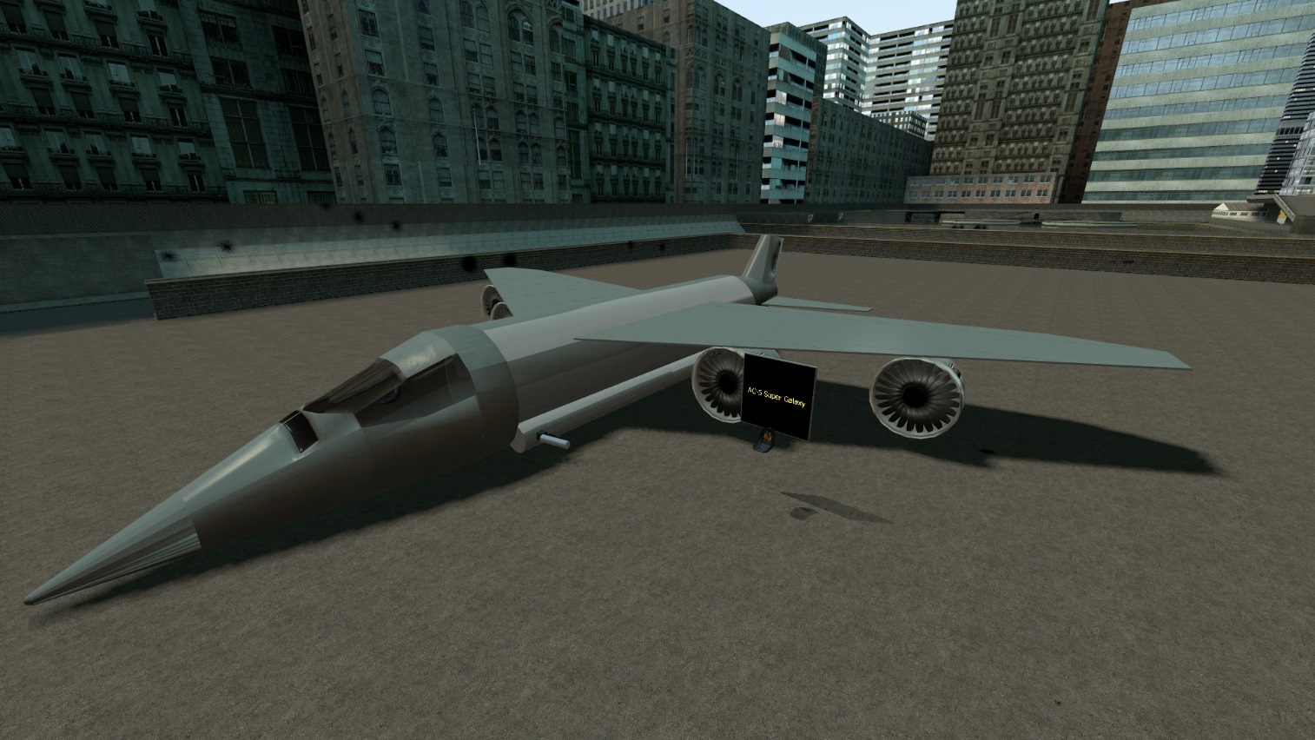

**Description:**

Huge AC-130 like plane. Has a gunner seat outside plane

**Controls:**

For pilot: MPFC plane

For gunner: LMB – guns, RMB - rockets

**Base prop:**

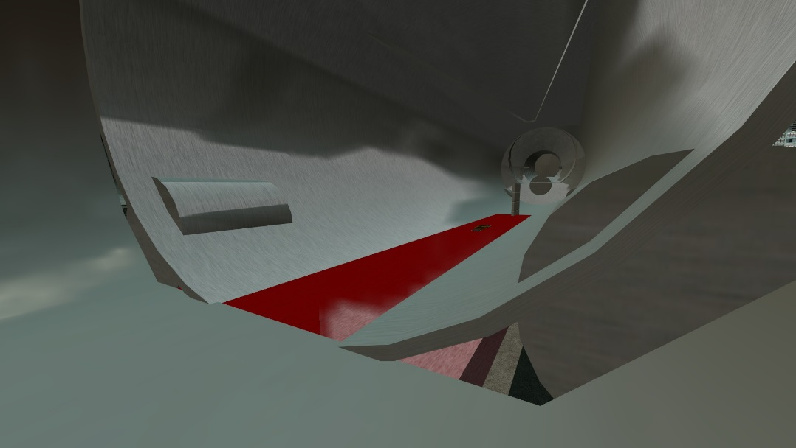

**Adeptus Custodes**

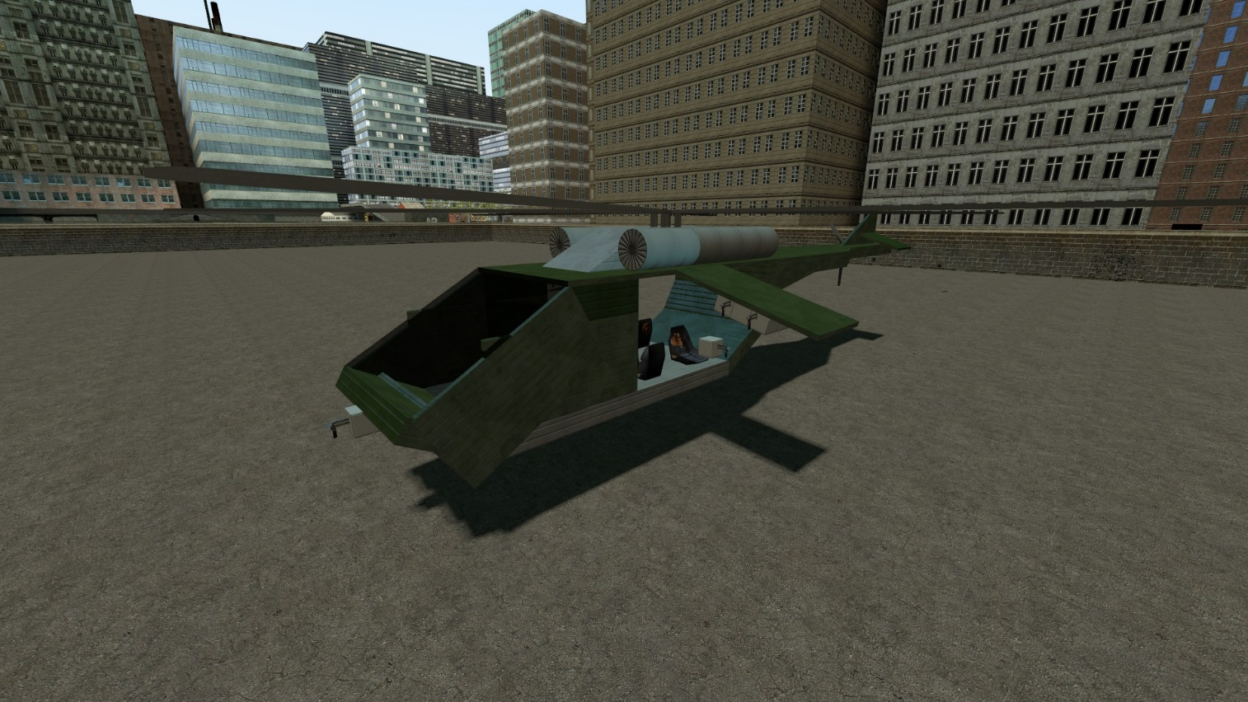

**Description:**

Transport helicopter. Was the 1st helicopter to be made from vanilla props. Front left seat is gunner, front right is pilot.

**Controls:**

Basic helicopter

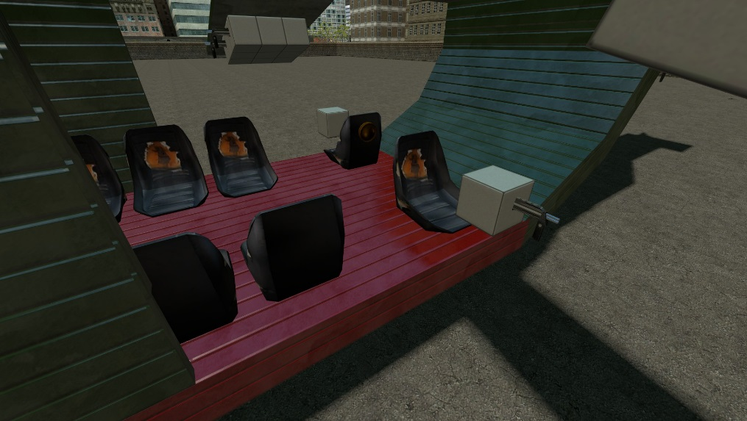**Base prop:**

**Blackbird**

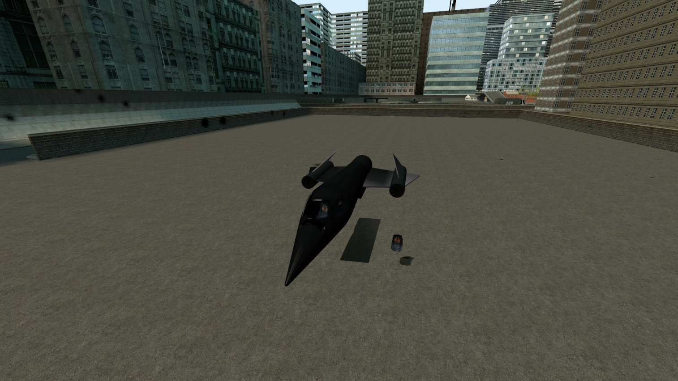

**Description:**

Fast plane. Spy version has a camera below the plane. Gunship has a controlled turret. Operator seat is outside of the plane

**Controls:**

For pilot: MPFC plane

For gunner: LMB – guns, RMB – rockets

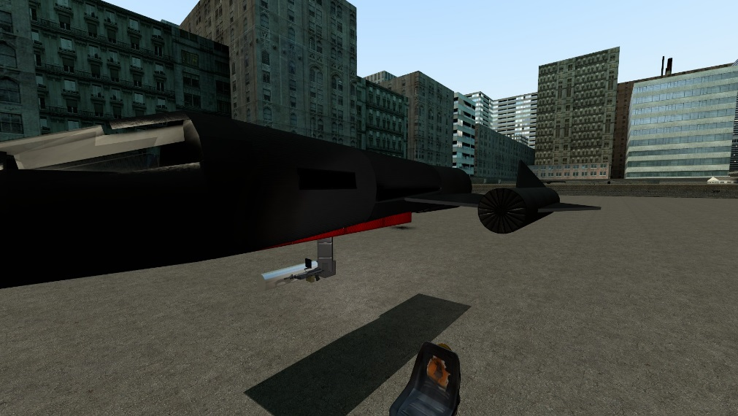**Base prop:**

**Mi-28**

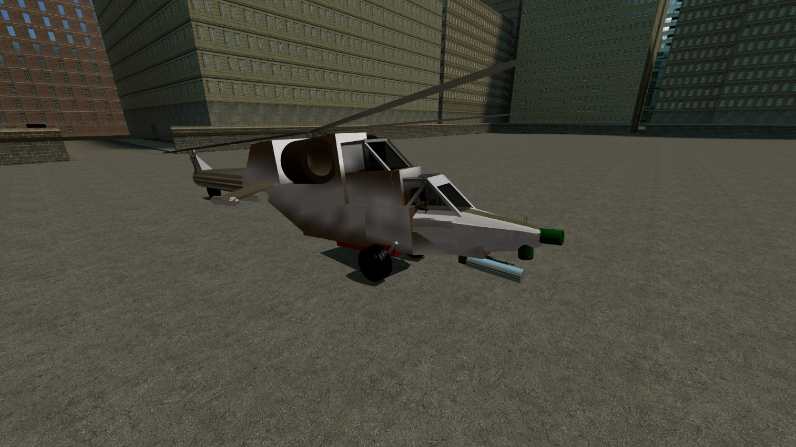

**Description:**

Based on original mi-28 by other player. Pilot is at back, gunner at front.

**Controls:**

Default Helicopter

For pilot: LMB - rockets

For gunner: LMB – gun, RMB – rockets

**Light Helicopter (transport)**

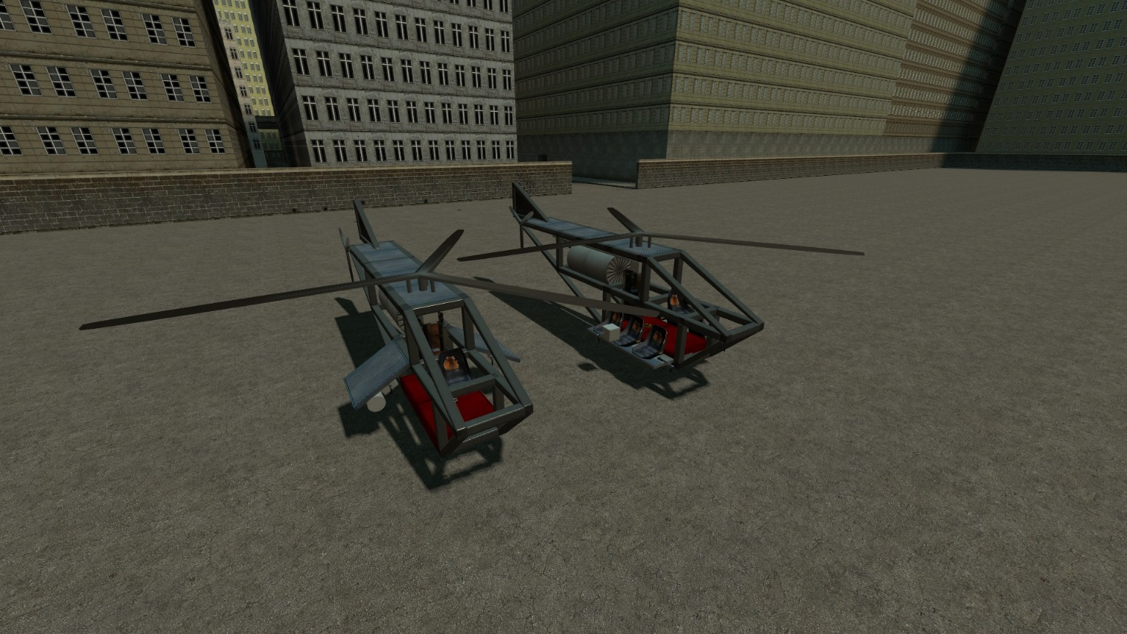

**Description:**

Light helicopter. The nontransport version has rocket pods.

**Controls:**

Default Helicopter

LMB – guns

RMB – rockets

**Mi-24**

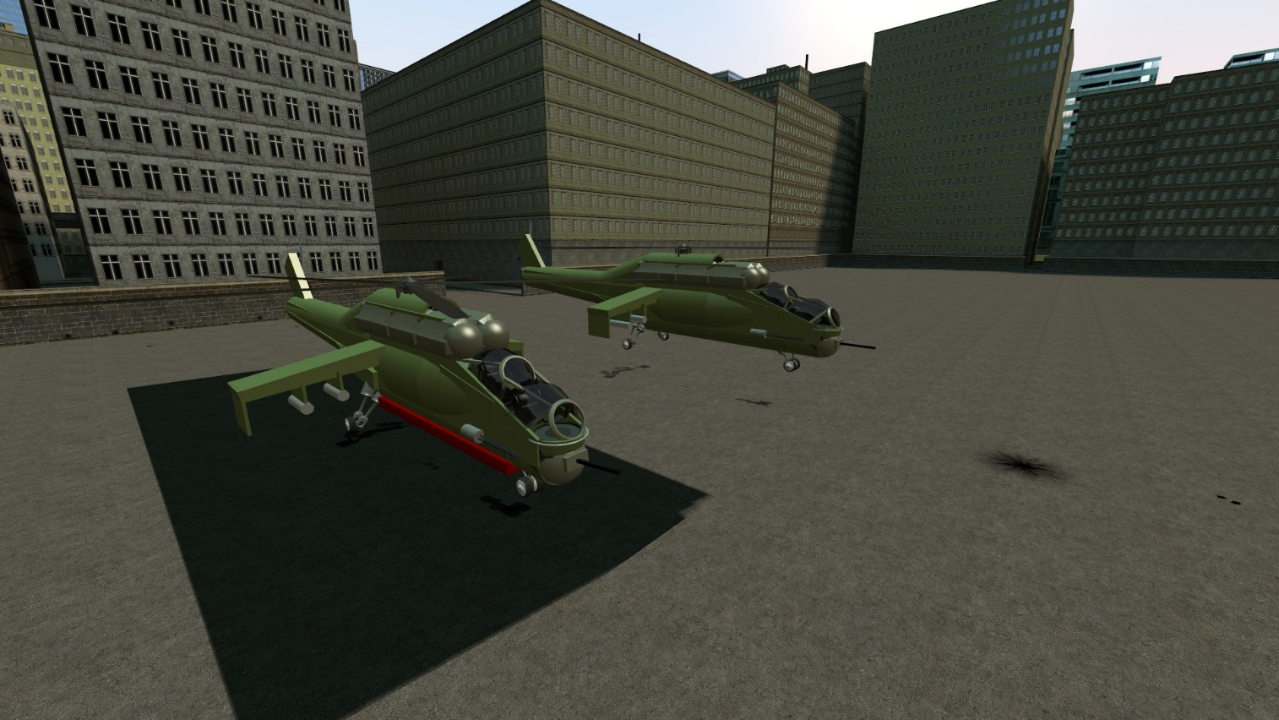

**Description:**

Based on the hull by other player (sorry mate, do not remember your nick), armed and enchanted by me.

Backseat is pilot seat, front is gunner. For solo version gunner seat is disabled (but still accessible) and the gun control is linked to pilot’s crosshair position

**Controls:**

Default helicopter

LMB – fixed high-damage side cannon

RMB – rocket pods

R (Solo only) – gunner turret

**MV Cloud car**

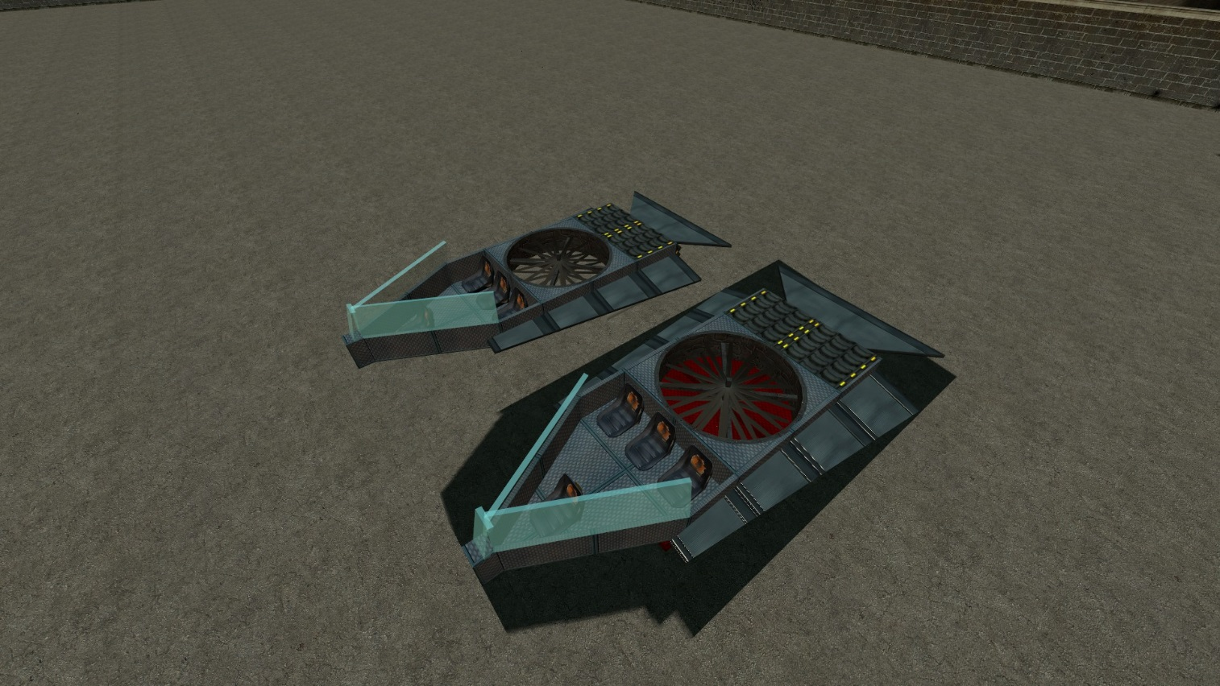

**Description:**

Armed. Pilot is the front seat

**Controls:**

Basic helicopter

LMB – guns

RMB – rockets

**MV Orca Big (Transport)**

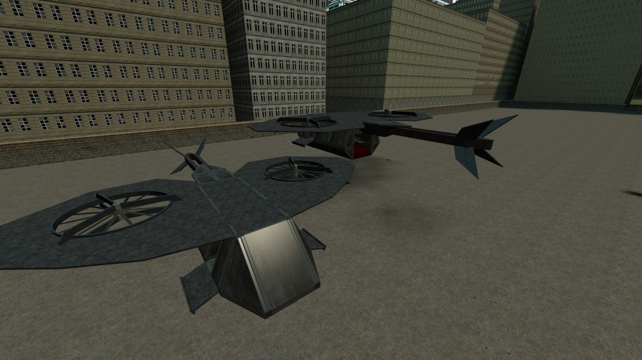

**Description:**

Huge transport aircraft from Orca series

**Controls:**

Basic helicopter

LMB – guns

RMB – rockets

**MV Orca Light**

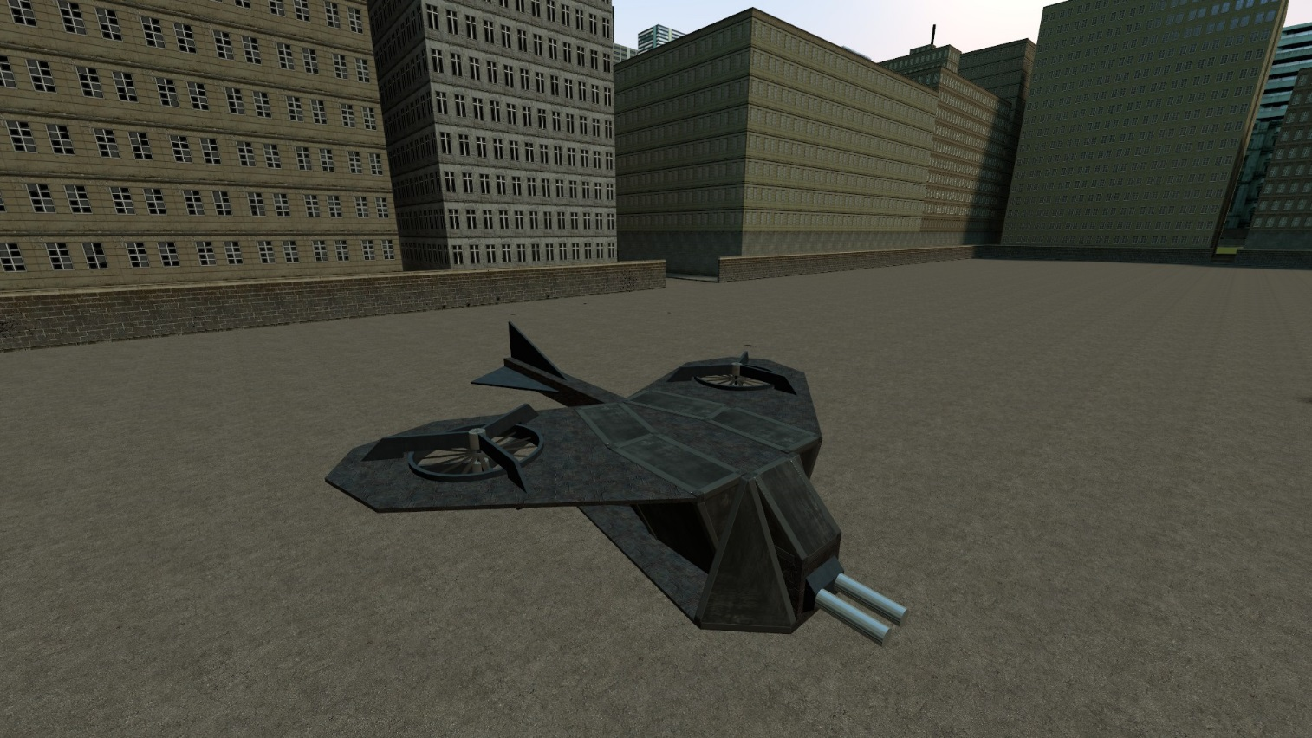

**Description:**

Very fast and agile Orca-series aircraft. Armed with a pair of explosive launchers

**Controls:**

Basic helicopter

LMB – Shoot

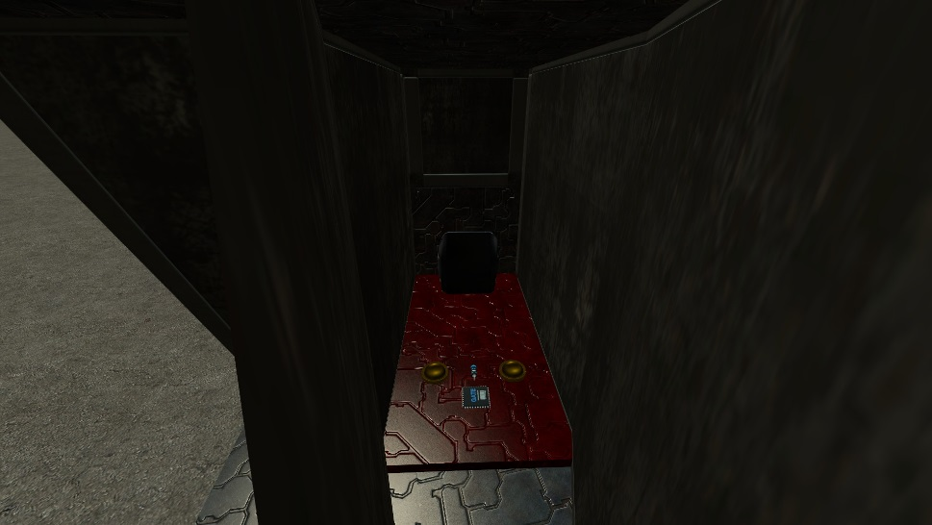**Basic prop:**

**MV Orca Pixy**

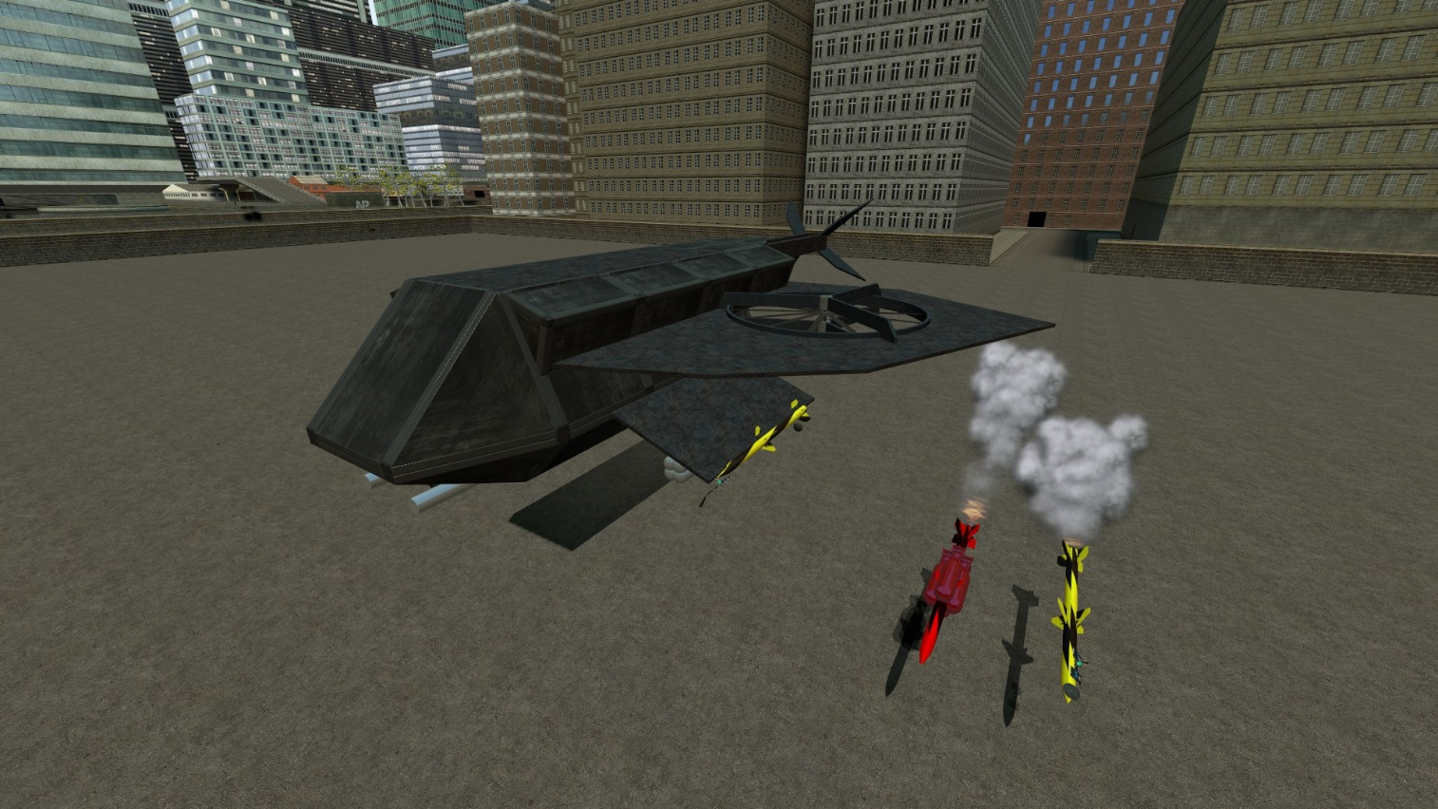

**Description:**

Heavy attack Orca-series aircraft. Has poor agility but high speed. Press shift to boost forward

**Controls:**

Basic helicopter. Bu do not fly it like a helicopter. Accelerate forward pressing Shift

R – Bombs

ScrollWheelUP and ScrollWheelDOWN – launch guided rockets from left/right pylon. Locks on the nearest vehicle to missile

LMB – guns

RMB – unguided rockets

**MV 88**

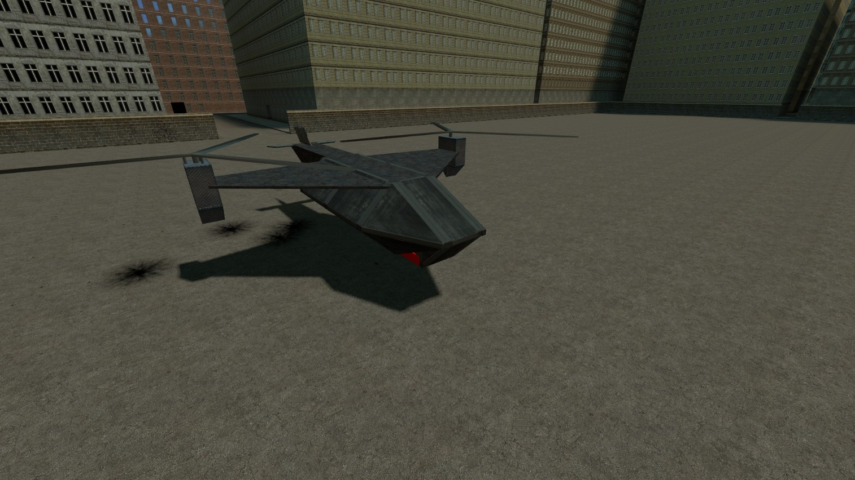

**Description:**

La Classique. Balanced attack craft

**Controls:**

Basic helicopter

LMB – guns

RMB – rockets

**Pitbull**

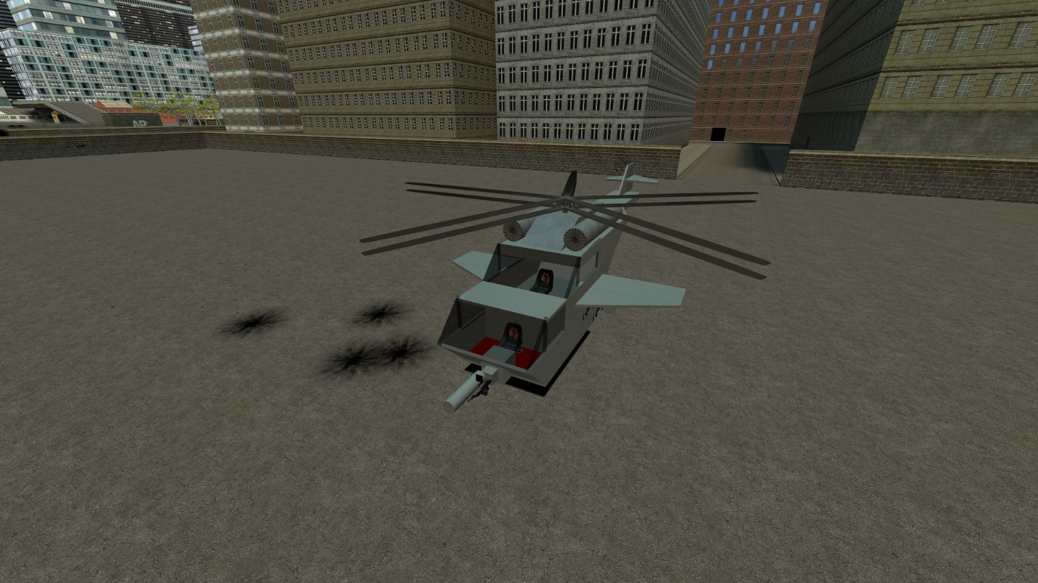

**Description:**

Attack helicopter. Gunner is at front, pilot is behind

**Controls:**

Basic helicopter

Pilot:

LMB – guns

RMB – rockets

Gunner: same

**Spaceship**

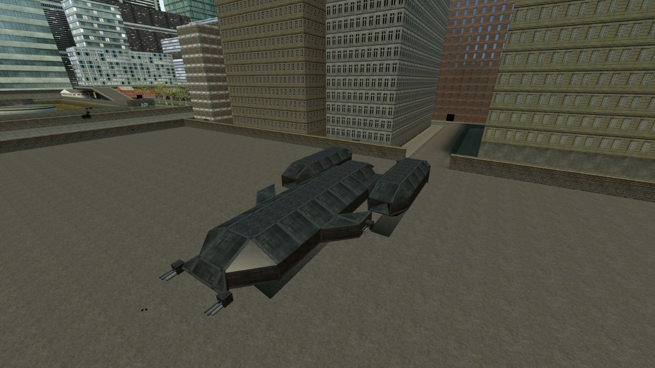

**Description:**

This bastard is made to rekt anything. Duo/Trio versions have extra gunner seats.

Be advised: It uses helicopter E2, but to move forward you need to hold Shift. If you have good position and want to soot – press Space to autohover.

**Controls:**

Basic helicopter

LMB – guns

RMB – rockets

Shift – Fly forward